Clwydian Hills Fell Race

The Clwydian Hills Fell Race is back with a new course. There is more scope for route choice, but don’t worry, Stony Gully on the final ascent to Moel Fammau is still included in the course.

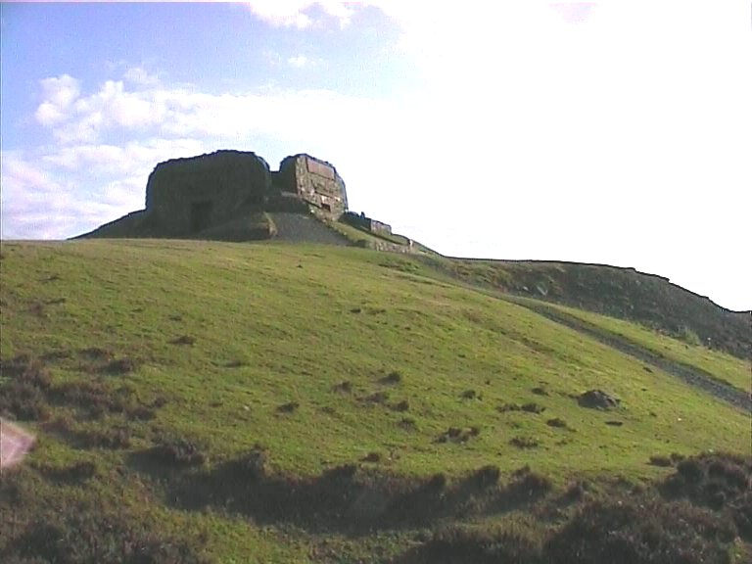

Sunday 6th. November at 11am.

Cilcain, Flintshire, N. Wales (GR SJ177653)

10 miles / 3100 ft. ascent

£3 on day only

Details : Peter Taylor 01352 741 822 (weekends)

Run under WFRA rules & insurance
Clwydian Hills Fell Race

The Clwydian Hills Fell Race is back with a new course. There is more scope for route choice, but don’t worry, Stony Gully on the final ascent to Moel Fammau is still included in the course.

Sunday 6th. November at 11am.

Cilcain, Flintshire, N. Wales (GR SJ177653)

10 miles / 3100 ft. ascent

£3 on day only

Details : Peter Taylor 01352 741 822 (weekends)

Run under WFRA rules & insurance

